**MATHE E-3 Assignment 10 Solutions 60 POINTS**

**Note: For all the following problems, be sure to label all axes and insert a title of some kind. Make sure your intervals on the axes are even. Remember, do not break the x-axis unless you feel extremely comfortable with graphing techniques. Use Examples 3 and 4 from the reading as models for problems 5-24.**

**Problems 1-4**

**For these problems**, **do not find regression equations. Here we are learning to interpolate and extrapolate using only two data values.**

The Life Expectancy of men and women born in the United States increased each decade from 1900 to 1950. The data for two of those decades appears below as well as a graph showing these data.

The data for two of those decades appears below as well as a graph showing these data.

|  |  |  |
| --- | --- | --- |
| **Year** | **Male Life**  **Expectancy (Years)** | **Female Life**  **Expectancy (Years)** |
| 1930 | 58.1 | 61.6 |
| 1940 | 60.8 | 65.2 |

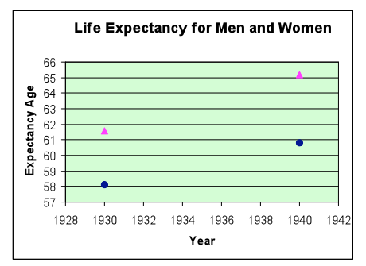

1)The values for men and women for this data have been plotted on the same set of axes. Draw in the lines on the chart above that connect the two values. You will have two separate lines: One for men and one for women. Notice how much steeper the line for women is. What does that tell you?

The steeper line for women tells you that the life expectancy for women is growing at a greater rate than the life expectancy for men.

**Use linear interpolation as demonstrated in Example 1 in the lecture notes to answer the questions that follow.**

1. Using linear interpolation, determine the approximate life expectancy of men and women in 1934.

**Male life expectancy**: Rate of growth:

60.8 - 58.1 = 2.7 =.27 per year

10 10

58.1 + (4*.27) = 58.1 + 1.08 =59.18 or you could round to 59.2 years.

**Female life expectancy**: Rate of growth:

65.2 - 61.6 = 3.6 =.36 per year

10 10

61.6 + (4*.36) =61.6 + 1.44 =63.04 or you could round to 63.0 years.

3) Using extrapolation, determine the approximate life expectancies for men and women in 1960.

**Male life expectancy**:

60.8 +( 20 *.27) = 60.8 + 5.4 =66.2 years.

**Female life expectancy**:

65.2 + (20*.36) =65.2 + 7.2=72.4 years

4) How confident are you of your predictions? Are you as sure of the extrapolation as the interpolation? Why or why not?

I am confident of my answers when interpolating between known values, but less confident when extrapolating. When you are extrapolating, there is a greater risk of error that the linear relationship no longer applies.

**Problems 5-11**

**Some economists believe that as the prime interest rate increases, the value of stocks decreases. The table below gives data collected over a certain time period, comparing the prime rate with the value of a particular stock.**

|  |  |  |  |  |  |  |  |
| --- | --- | --- | --- | --- | --- | --- | --- |
| **Prime Rate as a %** | 10 | 6 | 5 | 7 | 12 | 8 | 9 |
| **Stock Price in Dollars** | 60 | 80 | 90 | 70 | 50 | 65 | 60 |

5) Graph the data on a scatterplot below. Put the prime interest rate on the horizontal axis.

Why? The prime interest rate goes on the x axis because it is the independent variable.

6) By eye, draw below a regression line below that best represents the *trend* of the data.

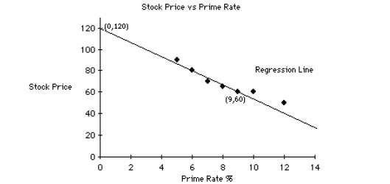

7) Describe in words the kind of correlation between the two variables. Give an estimate for

Pearson’s r-value. Description of correlation:

There is a strong negative correlation between the interest rate and the stock price.

Estimate of Pearson's r value:

Pearson's r value is approximately -0.7 or -0.8.

8) Find the equation of your regression line. In your work, show the calculation of slope. Use either the y-intercept that you drew above in your graph, or use a point on your line to calculate the y-intercept. Either method is acceptable.

The equation of my line:

Slope: points (0,120) and (9,60)

60-120 = -60 = -6.6666…

9-0 9

My y-intercept that I chose: (0,120) Equation:

Y=-6.7X+120

9) Describe in words what the slope AND y-intercept mean for these data. Meaning of slope:

The slope means that the value of the stock price drops an additional $6.70 for every additional percentage point increase in the prime interest rate.

Meaning of y-intercept:

The y-intercept means that theoretically the stock price would be $120 when the prime interest rate is zero.

10) Use your equation to predict the stock prices which correspond to the following **prime interest rates:** (do not estimate the answers from your graph although these estimates should match your answers calculated *from your equation*.)

**i) 11% y=-6.70*11+120 y= $46.30**

**ii) 1% y=-6.70*1+120 y=$113.30**

**iii) 15% y=-6.70*15+120 y=$19.50**

**iv) 30% y=-6.70*30+120 y=$-81.00**

11) Do any of your answers from question 10 look unrealistic? Discuss possible reasons.

There are definite reservations about a few of our predictions. As can be seen, if the prime interest rate goes up to 30% our equation predicts the value of the stock would be negative! This of course does not make sense. This is because we are extrapolating beyond known values.

**Problems 12-18**

**A pharmaceutical researcher wishes to know, as precisely as possible, the effect that a new drug will have on the human pulse rate. To investigate this effect, he administers different doses of the drug to each of seven randomly selected patients, and he notes the increase in their pulse rates one hour later.**

|  |  |  |  |  |  |  |  |
| --- | --- | --- | --- | --- | --- | --- | --- |
| **Patient** | **A** | **B** | **C** | **D** | **E** | **F** | **G** |
| **Dosage in cubic cm, cc’s** | 1.5 | 2 | 2.5 | 1.5 | 3 | 2 | 2.5 |
| **Change in the pulse rate in beats/min** | 8 | 10 | 14 | 10 | 15 | 11 | 12 |

12) Draw a scatterplot of the data. Put the dosage on the horizontal axis.

Why?__Dosage goes on the x axis because it is the independent variable. 13) Draw by eye the best fitting regression line below.

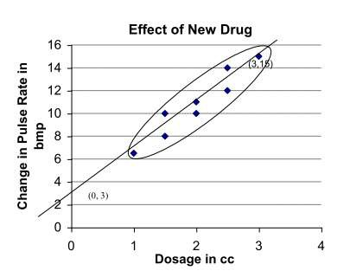

14) Describe in words the kind of correlation between the two variables. Estimate an 'r' value for your relationship.

Description of correlation:

There is a moderately strong positive correlation between the change in pulse rate and the dosage of the new drug.

Estimation of r value:

The r value would be approximately 0.6 or 0.7.

15) Find the equation of your regression line. In your work, show the calculation of slope. Use either the y-intercept that you drew above in your graph, or use a point on your line to calculate the y-intercept. Either method is acceptable.

Equation of my line:

Slope: points (0,3) and (3,15)

15-3 = 12 = 4

3-0 3

Y-intercept: I chose (0,3) Equation:

Y=4X+3

16) Describe in words what the slope and the y-intercept of your equation mean for these data.

Meaning of slope:

The slope means that the pulse rate changes by an additional 4 beats per minute for each additional cc of the new drug. You must remember that this does not mean that the additional cc of the drug caused the pulse rate to increase by 4 beats per minute. Other factors could very well have contributed to this increase.

Meaning of y-intercept:

The y-intercept means that the change in pulse rate is 3 beats per minute even when no drug is administered.

17) Use your regression line to predict the change in pulse rate which corresponds to the following dosages:

1. 2.8 cc's

y= (2.8*4) +3=14.2

1. 4.0 cc's

y= (4*4) +3 = 19

iii) 8.0 cc's

y = (8 * 4) +3 = 35

18) Do any of these answers seem unreasonable? Why?

The change in pulse rate of 35 predicted at a high dose of 8.0 cc of the drug indicates that this dose may be at a dangerous level. This suggests that perhaps the linearity of the regression line may not hold at these higher dosages and perhaps there is some sort of leveling off in the change in pulse rate. When extrapolating far from the known data, the predictions should always be suspect.

**Problems 19 – 24**

**A student athlete noticed that his race times were affected by the amount of sleep that he got the night before a race. To understand this factor better, he recorded his nightly sleep in hours and his performance in a 5k race the following day.**

|  |  |  |  |  |  |  |
| --- | --- | --- | --- | --- | --- | --- |
| Hours of sleep | 8 | 7.5 | 5.5 | 9 | 6 | 8.5 |
| Time (minutes) | 16.5 | 16.3 | 17.2 | 16.2 | 17 | 16 |

19) Graph the data on a scatterplot below. Put the hours of sleep on the horizontal axis.

Why? Hours of sleep is the independent variable.

_

20) By eye, draw below a regression line below that best represents the *trend* of the data.

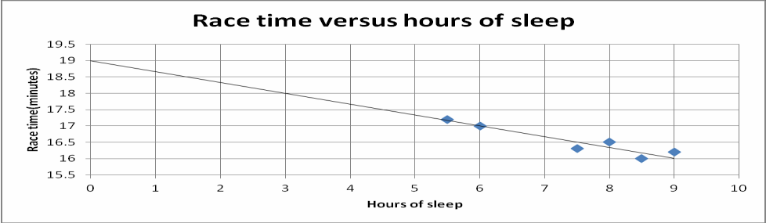

21) Describe in words the kind of correlation between the two variables. Give an estimate for

Pearson’s r-value.

Description of correlation:

Moderately strong negative correlation

Estimate of Pearson's r value: -.7

22) Find the equation of your regression line. In your work, show the calculation of slope. Use either the y-intercept that you drew above in your graph, or use a point on your line to calculate the y-intercept. Either method is acceptable.

Points (6,17) (0,19)

Slope = 19-17 = 2 = -.33

0 - 6 -6

Y intercept:

Use point on graph, or calculate: Using point (6,19)

17=-.33(6)+b

17=-2+b

19=b

Y = - .33X +19

23) Describe in words what the slope AND y-intercept mean for these data. Meaning of slope:

For every 1 hour increase in sleep, the athlete's race time improves (or goes down) by .33, or 1/3, of a minute (20 seconds).

Meaning of y-intercept:

At 0 hours of sleep (if the athlete got no sleep), his race time would be 19 minutes.

24) Use your equation to predict the race times which correspond to the following nightly sleep times**:** (do not estimate the answers from your graph although these estimates should match your answers calculated *from your equation*.)

i) 4 - . 3 3 ( 4 ) + 1 9 = - 1 . 3 2 + 1 9 = 1 7 . 6 8 m i n u t e s

ii) 7 - . 3 3 ( 7 ) + 1 9 = 1 6 . 6 9 m i n u t e s K2iii) 10 - . 3 3 ( 1 0 ) + 1 9 = 1 5 . 70 m i n u t e s